|  |  |
| --- | --- |
| **Version** | **Modified by** |
| **1.0** | **Nagapuri Rajesh Kumar** |

**Summary:**

|  |
| --- |
| This document explains how to setup AWS SMS on vCenter |

**Audience:**

|  |
| --- |
| * GIS Systems Administrators |

**AWS SMS for vCenter**

**Summary:**

AWS Server Migration Service automates the migration of on-premises VMware virtual machines to the AWS Cloud and Amazon EC2. AWS SMS incrementally replicates your server VMs as cloud-hosted Amazon Machine Images (AMIs). Working with AMIs, you can easily test and update your replicated, cloud-based VMs before deploying them in production.

**Key Features:**

* **Simplify the cloud migration process.** You can begin migrating a group of servers with just a few clicks in the AWS Management Console. After the migration has initiated, AWS SMS manages all the complexities of the migration process, including automatically replicating volumes of live servers to AWS and creating AMIs periodically. You can quickly launch EC2 instances from AMIs in the console.
* **Orchestrate multi-server migrations.** AWS SMS orchestrates server migrations by allowing you to schedule replications and track progress for a group of servers. You can schedule initial replications, configure replication intervals, and track progress for each server using the console.
* **Test server migrations incrementally**: With support for incremental replication, AWS SMS allows fast, scalable testing of migrated servers. Because AWS SMS replicates incremental changes to your on-premises servers and transfers only the delta to the cloud, you can test small changes iteratively and save on network bandwidth.
* **Support the most widely used operating systems**. AWS SMS supports the replication of operating system images containing Windows, as well as several major Linux distributions.
* **Minimize downtime.** Incremental AWS SMS replication minimizes the business impact associated with application downtime during final cutover.

**Requirements:**

* IAM User/Policies/roles on AWS account
  + We created “**awstrustvc**” in AWS PROD account
  + Attached “**ServerMigrationConnector**” (AWS managed policy) and “**sms**” role
* AD/vCenter Accounts and permissions
  + Created an AD account “**awsconnectvc**” (make a note of password)
  + Attached “**AWSSMSConnecot”** Role in vCenter

## Deploying the SMS Connector Virtual Appliance

The connector is packaged as a virtual appliance. To deploy the connector, complete the following procedure.

**To deploy the Connector virtual appliance**

|  |  |
| --- | --- |
| 1. Sign in to vCenter as a VMware administrator. |  |
| 1. From the **File** menu, click **Deploy OVF Template**. Enter the following URL into the **Deploy from a file or URL**field and then click **Next**:   https://s3.amazonaws.com/sms-connector/AWS-SMS-Connector.ova |  |
| 1. Click NEXT |  |
| 1. Select Data Center |  |
| 1. Select Cluster |  |
| 1. Select Data Store |  |
| 1. Select Disk Format |  |
| 1. Select required subnet NIC |  |
| 1. Click on Finsh |  |
| 1. AWS SMS Connector will be deployed on vCenter |  |

## (Optional) Configuring Network Settings

You can configure various network settings using the connector command line interface (CLI).

**To update your network settings using the connector CLI**

1. Locate the connector VM in the vSphere client, right-click it, and select **Open Console.**
2. Log in as ec2-user with the password ec2pass.
3. Run the **sudo setup.rb** command. This command displays the following menu:
4. Choose one of the following options
5. 1. Reset password
6. 2. Reconfigure network settings
7. 3. Restart services
8. 4. Factory reset
9. 5. Delete unused upgrade-related files
10. 6. Enable/disable SSL certificate validation
11. 7. Display connector's SSL certificate
12. 8. Generate log bundle
13. 9. Exit

Please enter your option [1-9]:

1. Type 2, and then press Enter. The command displays the following menu:
2. Reconfigure your network:
3. 1. Renew or acquire a DHCP lease
4. 2. Set up a static IP
5. 3. Set up a web proxy for AWS communication
6. 4. Set up a DNS suffix search list
7. 5. Exit

Please enter your option [1-5]:

Use these options to complete the following tasks:

* 1. Renew your DHCP lease, or re-enable DHCP after setting up a static IP address.
  2. Set up a static IP address for the connector. When prompted, enter the static IP address, netmask, gateway, and DNS servers.
  3. Configure the connector to use a corporate web proxy. When prompted, enter the proxy IP address, port, and an optional user name and password to log in to the proxy. If you need to use authentication for the web proxy, note that the connector supports only password-based authentication.

**Note**

This option requires that you've set your initial password by logging into the connector using https://ip_address/, where ip_address is the IP address of the connector management console

* 1. Configure the DNS suffix search list so that connector can migrate VMs from the ESX host. You do not need to do this if vCenter displays all ESX hosts using fully-qualified domain names or IP addresses.

## AWS Connector Registation with AWS Account and vCenter

|  |  |
| --- | --- |
| 1. Open browsere and enter IP/DNS name of the connector |  |
| 1. Create Password for 1st time |  |
| 1. Enter Password which is created |  |
| 1. Click on “Next” |  |
| 1. Un-Select both check marks and click Next |  |
| 1. Upload file | Which is generated whill doing Setting Up the Trust Relationship |
| 1. Enter the Access Key and Secret Key which is generated in IAM user and click Next | C:\Users\nagra14\AppData\Local\Microsoft\Windows\INetCache\Content.Word\1.png |
| 1. Enter vCenter server name and genric account user name/password and select check box | C:\Users\nagra14\AppData\Local\Microsoft\Windows\INetCache\Content.Word\2.png  Note: We need to re-registor in case there is a password change |
|  |  |
| 1. Trust Certificate | C:\Users\nagra14\AppData\Local\Microsoft\Windows\INetCache\Content.Word\3.png |
| 1. Setup is completed |  |
| 1. Login into AWS account and select “Server migration” we can see the connectors and their status |  |
| 1. Upgrade of connecot | Enable Auto-Upgrade or Click on Upgrade when you see a upgrade pop-up on top of screen. |

**Migration flow:**

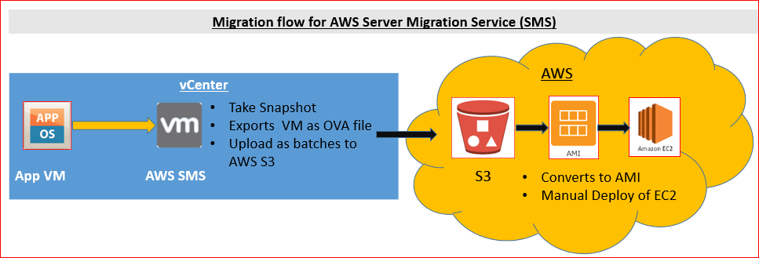

**References Link:**

<http://docs.aws.amazon.com/server-migration-service/latest/userguide/server-migration-ug.pdf>

Notes